**2016YL_LD6034BVZ01: Object Oriented and Web Programming**

Northumbria University, Faculty of Engineering and Environment

Assignment A



Alexandru Sburlescu

W16037814

Table of Contents

Introduction 3

UI Guidelines 3

UI Design basics 3

UI Usability 4

UI Accessibility 5

Conclusions 6

Bibliography 7

# Introduction

This report will analyze the way that a website when properly designed, with usability and accessibility in mind, can ease and enrich the user experience when browsing. Design, usability and accessibility are related in goals and their guidelines overlap, therefore they are usually addressed together. In some cases accessibility may have to be addressed separate, especially when dealing with the visually impaired. User interface guidelines are what designers and developers use as a main source of recommendation.

# UI Guidelines

The UI guidelines are recommendations that designers and developers use in order to create a user interface for their applications. They can be either local guidelines, created by the companies who have their own styles or general standards that are used by the software platforms (Msdn.microsoft.com, 2017). The problem with the guidelines is that even though it can make the user experience easier, since they are dealing with something they have used before, they can be too general and if the need arises for a specific design, guidelines are too broad and won’t give enough information to proceed.

Guidelines should be considered as a starting point. They do lead to UI consistency but it does not ensure usability if the design is flawed. Thorough UI testing must be done with users to make sure that the product is suited for the task, not just easy to use.

# UI Design basics

One of the guides in UI design basics is the Usability.gov website, maintained by the US Government which lists some of the basics that should not hinder development, whilst at the same time keeping things easy to understand for the end-user. A simple interface, common UI elements throughout the website, strategic use of color and textures and communicating errors to users are some of the basic, must follow, rules of UI Design (Usability.gov, 2017).

For the website required by the assignment I have kept these simple guidelines in mind and used a common header and footer and the same color scheme throughout the pages. The tables, menus and buttons are formatted using bootstrap so they are responsive, no matter the device used to view the pages. Bootstrap is a web development framework designed by a team at Twitter and is an open source project. It includes CSS styles, Jscript libraries and HTML files. It is a way to easily develop responsive websites rather than making them from scratch (Techterms.com, 2017).

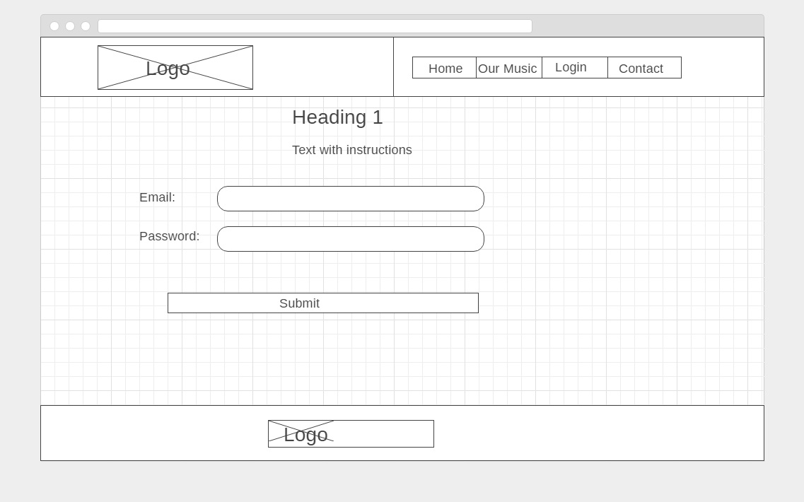

# UI Usability

Usability measures the interactive user experience that associates with the user interface. A user-friendly interface is supposed to be easy to learn, it helps finish tasks and goals efficiently and is engaging to use (Usabilityfirst.com, 2017). There are a number of factors at play when usability comes to mind. How it fits the user needs, how easily tasks can be completed and how the website fits the user’s expectations. But this is all from the user’s point of view so it is important to test the interface before releasing a product. It can mean the difference between the success or the failure of the business.

For the virtual playlist system, a few key elements of design have been used to ensure usability. Clear messages are displayed across the website, telling the user when they can use the application and how. The first page welcoming the users is simple and is designed with ease of use in mind. A message and a button captioned “Start Now” has been used. When the user clicks on the button he is taken to the main part of the website. There a message to login has been used if the user session has not started. The same message will change to a message to add songs to their playlist when they are logged in.

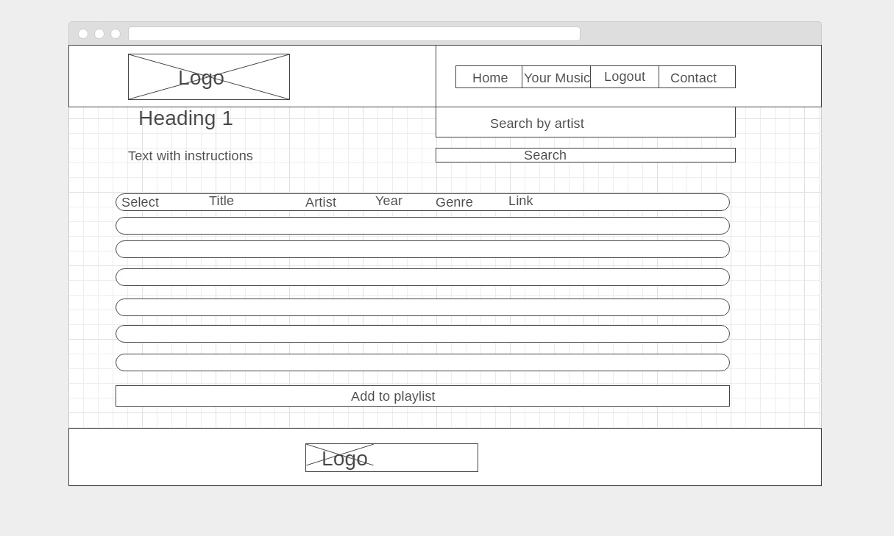

The menu part of the system is highly visible and responsive. It uses common known key words as “Login”, “Register” or “Contact” that have been used throughout website building, no matter the page they are currently in. The menu also changes when the user logs in, into “Logout” with “Login” and “Register” items disappearing.

# UI Accessibility

“Web Content Accessibility Guidelines (WCAG) is developed through the W3C process in cooperation with individuals and organizations around the world, with a goal of proving a single shared standard for web content accessibility that meets the needs of individuals, organizations, and governments internationally” (W3C Web Accessibility Initiative (WAI), 2017) .

WCAG 2.0 covers twelve principles when it comes to web accessibility and it deals with being able to provide alternative content to visually or hearing impaired users who want to access the website. Text alternatives for non-text context such as short descriptions for images and labels for form controls and other user interface components. For the multimedia part of the website to provide text transcripts and captions of audio content, text narration for the audio part of a video file or sign language interpretation of the audio content.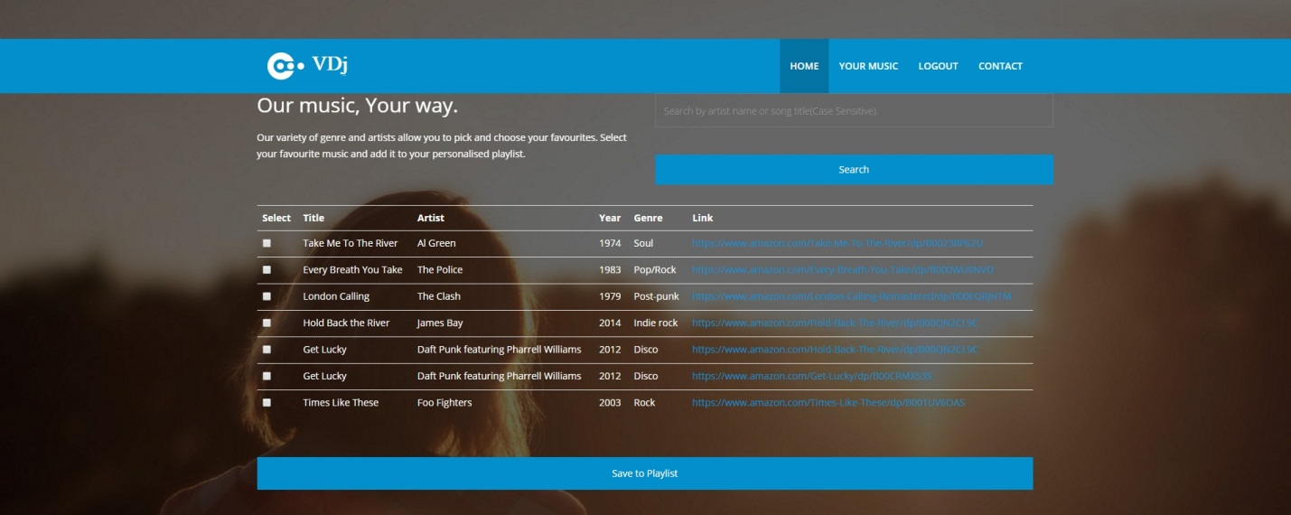

Another important part is the way that content is organized so the users can easily navigate and find content. Also the way that the text is displayed is important. It needs to be readable and understandable. For the website I have used fade-in effects in order to maximize the impact that the text has on the user. It was used to draw their attention to the instructions, on how to use the application, while at the same time keeping in mind usability.

# Conclusions

Due to the restraints imposed from the beginning in the assignment brief, this project does not have any multi-media aspects (e.g. video or audio content) therefore there is no need for text transcripts or audio captioning for the hearing impaired. However, for the visually impaired there could have been a high visibility theme in use, which has not been deployed due to time constraints. 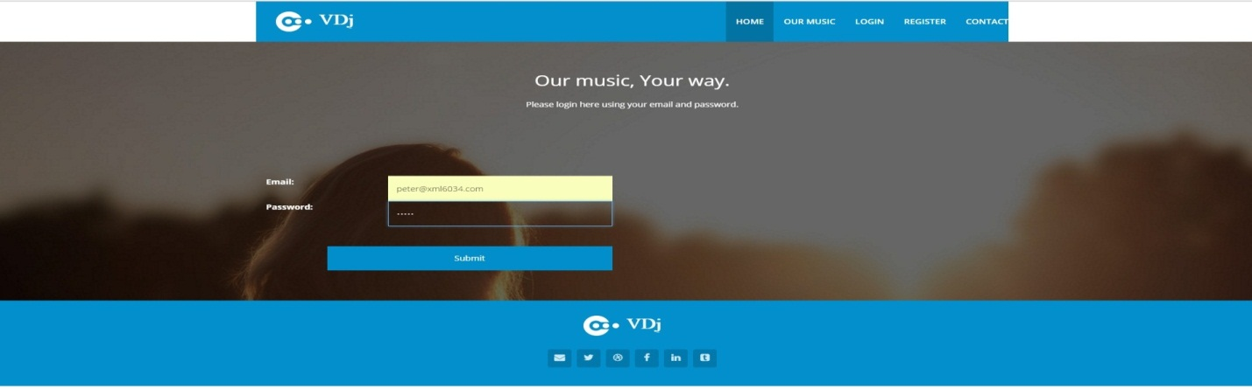

The current visual theme of white and blue against a photographic background does not fully satisfy the need of the visually impaired however it is designed with visibility in mind and the white/blue theme has been chosen to cater to the color blind, especially those in the red-green spectrum.

# 

# Bibliography

Msdn.microsoft.com. (2017). UI Guidelines vs. Usability Testing. [online] Available at: https://msdn.microsoft.com/en-us/library/ms997578.aspx [Accessed 25 Apr. 2017].

Techterms.com. (2017). Bootstrap Definition. [online] Available at: https://techterms.com/definition/bootstrap [Accessed 21 Apr. 2017].

Usability.gov. (2017). User Interface Design Basics | Usability.gov. [online] Available at: https://www.usability.gov/what-and-why/user-interface-design.html [Accessed 23 Apr. 2017].

Usabilityfirst.com. (2017). Usability First - Introduction to User-Centered Design | Usability First. [online] Available at: http://www.usabilityfirst.com/about-usability/introduction-to-user-centered-design/ [Accessed 28 Apr. 2017].

W3C Web Accessibility Initiative (WAI). (2017). WCAG Overview ◦ Web Accessibility Initiative ◦ W3C. [online] Available at: https://www.w3.org/WAI/intro/wcag [Accessed 27 Apr. 2017].